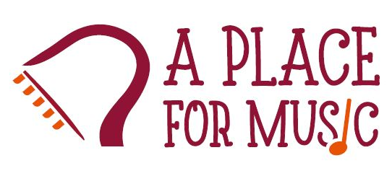

A Place For Music Students Lesson Policy – January 2026
The purpose of this document is to inform you of my lesson policies regarding payments, cancellations/missed lessons.

Lesson Payments:
Payment method - Payments are accepted via cash or through Zelle. In order to retain your weekly recurring time slot, payment must be paid in full each month prior to the lesson. One month’s payment will cover 4 weekly lessons. A friendly reminder will be sent out several days beforehand.

Missed Lessons:
Reimbursement will not be given for any absence/missed lesson. If absence from a lesson is unavoidable, you may either schedule a make-up lesson (see below) or forfeit the lesson.

Make-up Lessons:
It is your responsibility to contact me to make up any missed lesson. Make-up lessons will only be available within 14 days of the absence.

IMPORTANT - Make-up lesson schedule:
Make-up lessons are available on Tuesday (5:30-7pm) or Saturday (1pm-4pm), depending on availability.
If the lesson is not made-up within 14 days, the lesson will be forfeited.
Refunds will not be given for unused lessons.

Student Cancellation and Makeup Policy:
Acceptable Cancellation – 24 hours or greater:
This includes any cancellation such as family emergencies, traffic, school issues, illness, parents’ overtime at work, transportation issues, etc.
It is up to the student to take advantage of makeup lessons within 14 days; otherwise, no refunds will be issued.

Unacceptable Cancellation – Less than 24 hours:
Cancellations received with less than 24 hours’ notice for any reason will be required to make up the lesson within 3 days.
It is up to the student to take advantage of makeup lessons within 3 days; otherwise, no refunds will be issued.

Holidays/Inclement Weather/Teacher Illness Policy:
In the event your lesson falls on a holiday, or in case of inclement weather where the roads are unsafe for me to drive, or due to my potential personal illness, you will be notified by text to make up the missed lesson.
It is up to the student to take advantage of makeup lessons within 14 days; otherwise, no refunds will be issued.

Suspension of Lessons:
Lessons continue on an ongoing, weekly basis. Lessons will only cease in the following scenario:
You request in writing for lessons to be stopped (see “Withdrawal” section below).

Withdrawal from Lessons:
Voluntary withdrawal or extended vacation (up to 1 month per year).
I support family vacations. If you plan to take an extended vacation for up to 1 month, OR plan to voluntarily terminate lessons, please communicate in writing with your requested withdrawal and return dates (if applicable) so that all lessons paid for will be taken prior to your vacation or lesson termination. Refunds will not be given for unused lessons.

If your vacation extends beyond 1 month, a monthly payment must be made prior to your vacation in order to hold your slot when you return.

Please feel free to reach out to me with any questions at (908) 943-7884.
Thank you.

Ruth Moros
A Place for Music Students

Client Agreement

I have read and agree to this Lesson Policy.

Name:
Signature:
Date:

